**Database Title**

# Project Team (3 students)

|  |  |  |
| --- | --- | --- |
| **No** | Stu-Number | Name Surname |
| 1 | 17070006023 | Efe Can Nerman |
| 2 | 17070006020 | Gökay Şendil |
| 3 |  |  |

**PHASE 4- USER INTERFACE (Due Jan, 10)**

# Graphical User Interface

Prepare a front-end program to display database modifications, Can be desktop, mobile native or web based, Put your GUI snaphot below and explain.

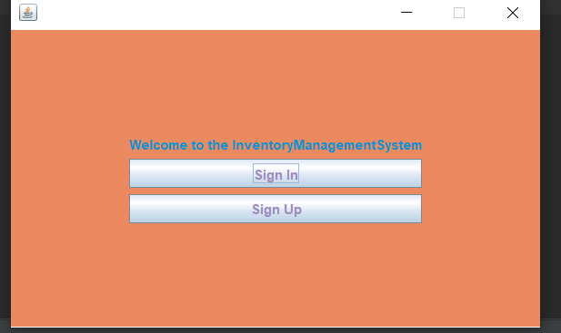

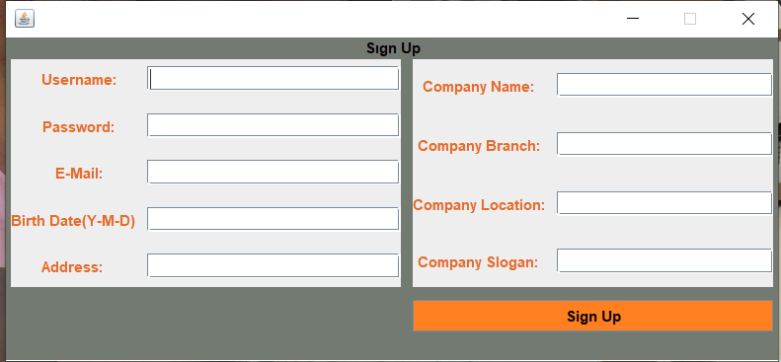

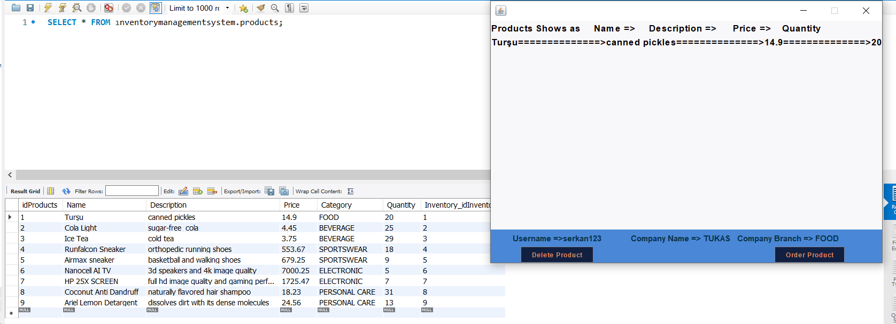

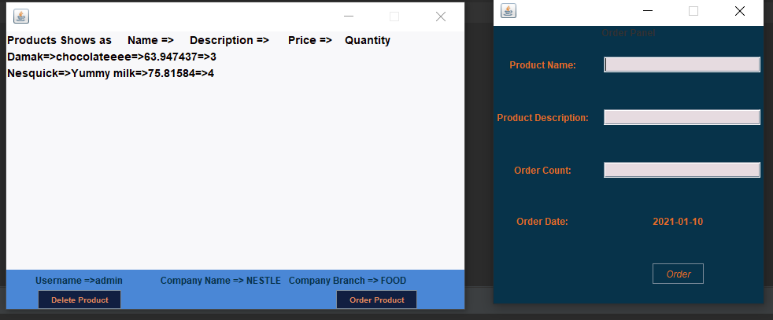

# Presentation

* Prepare a presentation for database, tables and relations with SQL examples---10 slides with a running application
* Be ready to answer immediate questions---for each team member 2 questions at least

# Discussion and self-evaluation

Write a paragraph to evaluate this project study. List some proposals to make it happen better.

* This project was done to perform inventory management
* Proposal: Maybe it could be made commercially available by including customer service
* Product could be followed with live graphic streaming

# Peer-Review ? (table filled)

Write here for each member of your group, list of gains, benefits

* List of Gains:
* We have learned to manipulate data with transactions in the database
* We learned to design interfaces in java and create an interface database connection
* We learned how to write proper code and the importance of team harmony in a real project.
* Benefits:
* We gained efficient information in java and sql area
* We learned desktop application development techniques and database editing

There will also be a peer evaluation session on SAKAI.